Review Meeting- xxx
Your name
BioPhotonica Lab, Centre for Biomedical Engineering, IIT Delhi
2024-10-01 (Tuesday)
Title: Write the report title here. “Example: OCT Imaging of Diabetic Retinopathy”
Abstract: Summarize the report as an abstract- “very short report”. Use "Normal 1stpara style" to write the abstract. Please summarize the abstract as: i) what you did, ii) the main results, and iii) the conclusion.

1. Introduction
A living, unstained cell absorbs almost no light; it mainly changes the light's phase, through small differences in refractive index between its interior and the surrounding medium. An ordinary camera measures only intensity, so such a phase object is invisible exactly at the plane where it is best focused, and becomes visible only once defocus has converted some of its phase structure into intensity contrast. Fourier ptychographic microscopy (FPM) [1–3] is one of the capable tools built for this kind of sample: it stitches many low-resolution images, captured under sequentially varied LED illumination angles, into one high-resolution, wide-field, phase-resolving reconstruction. But that reconstruction is iterative and needs a working defocus estimate before it starts, and the founding FPM paper proposes, the most direct way to estimate defocus is to try several candidate values, reconstruct at each, and keep the sharpest [1].

1.1. Subsection 1
All equations should be numbered as follows:
$$x=\frac{-b±\sqrt{b^{2}-4ac}}{2a}$$ | (1)
To write the equation, use the insert > Equation function of a word.

2. Theoretical Background
A thin sample is described by a complex transmittance,
$$O\left(x,y\right)=A\left(x,y\right)·e^{iφ\left(x,y\right)}$$
where A is amplitude transmission and φ is phase delay. A pure phase object has $A ≡ 1$ and carries all its structure in φ; because a detector records only intensity, $|O|² = 1$ everywhere at the object itself, independent of φ. Propagating the field a distance z under the angular spectrum method multiplies its spectrum by $exp\left[iz·k_{z}\left(f_{x},f_{y}\right)\right],$
$$k_{z}\left(f_{x},f_{y}\right)=2π\sqrt{\left(1/λ^{2}-f_{x}^{2}-f_{y}^{2}\right)}$$
recorded intensity then follows the Transport of Intensity Equation,
$$∂I/∂z∝-∇^{2}φ$$
meaning phase curvature is converted into visible intensity only once z departs from zero. Any sharpness metric built on intensity, most simply the Brenner gradient [4],
$$B\left(z\right)=\sum_{\left(x,y\right)}{{\left[I_{z}\left(x+2,y\right)-I_{z}\left(x,y\right)\right]}^{2}}$$
1therefore, starts from an intrinsically weak signal at true focus for a phase sample, and grows away from it, opposite to the ordinary amplitude-object case where B(z) peaks at focus.
Two independent frequency limits bound what such a system can transmit. A microscope objective lens has a finite size, and therefore can only collect light travelling within a limited range of angles from the sample. Because higher spatial frequencies in an object correspond to light bent off at steeper angles (fine detail scatters light more widely than coarse detail), a lens with a limited collection angle can only pass spatial frequencies up to some maximum value. The objective admits spatial frequencies up to NA/λ. The lens is not the only thing that can throw away fine detail. A digital camera sensor is a grid of individual pixels, and a grid of finite pixel size has its own, completely separate limit on what detail it can faithfully record, described by the Nyquist-Shannon sampling theorem. The camera pixel grid, of pitch p referred to the object plane, admits frequencies only up to 1/(2p). Whichever is smaller sets the system's effective bandwidth, and for the hardware used throughout this paper (λ = 0.532 μm, 2.5 μm pixels, 2× magnification) the two coincide at NA = 0.213.
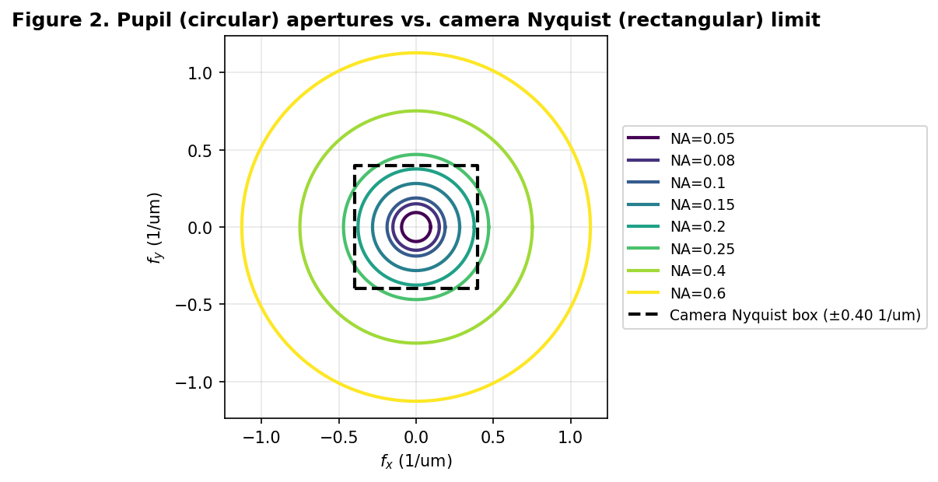
Figure 1 The lens's circular light-collecting aperture, drawn for several different NA values, plotted against the camera sensor's own fixed, rectangular Nyquist limit. Wherever the lens's circle extends beyond the sensor's box, the camera, not the lens, has become the true bottleneck.

Below this NA, the lens is the limiting factor; above it, the camera sensor is.
A separate and purely numerical constraint applies once defocus is simulated over a wide range: the propagation phase factor is a chirp whose local oscillation rate grows with z, and once that rate exceeds one half-cycle per grid sample, the discrete calculation aliases and silently returns an incorrect result, here acting on the simulation rather than a camera. A band-limited correction that removes only the specific frequencies that would alias at a given z keeps the calculation valid well beyond this naive bound, and is used wherever this paper reports results at large defocus.

3. Methodology
A single, fixed set of simulation parameters, summarised in Table 1, was used throughout; deviations are noted where they occur.
Table 1 Simulation parameters
Parameter | Value
Wavelength | 0.532 μm
Magnification | 2.0×
Camera pixel pitch | 2.5 μm (1.25 μm at the object plane)
Lens/camera crossover NA | 0.213
Simulated capture grid | 128×128 px (main results), 256×256 px (extended-range results)
NA values tested | 0.05, 0.08, 0.10, 0.15, 0.20, 0.25, 0.40, 0.60
Default defocus range | ±50 μm (±300 μm for extended-range results)
Test objects were complex transmittance fields
$O\left(x,y\right)=A\left(x,y\right)·e^{iφ\left(x,y\right).c}$ built from a standard cameraman amplitude pattern and a Gaussian-smoothed phase pattern, with c defining pure-amplitude, weak-phase, strong-phase, sharp-edged-phase, and two mixed amplitude/phase categories (Figure). Defocus was simulated by cropping the pupil-limited region of the object's spectrum, applying the propagation phase factor (with the band-limiting correction where noted), and inverse-transforming to intensity. Sharpness was scored with the plain (unnormalized) Brenner gradient, computed once per candidate z.
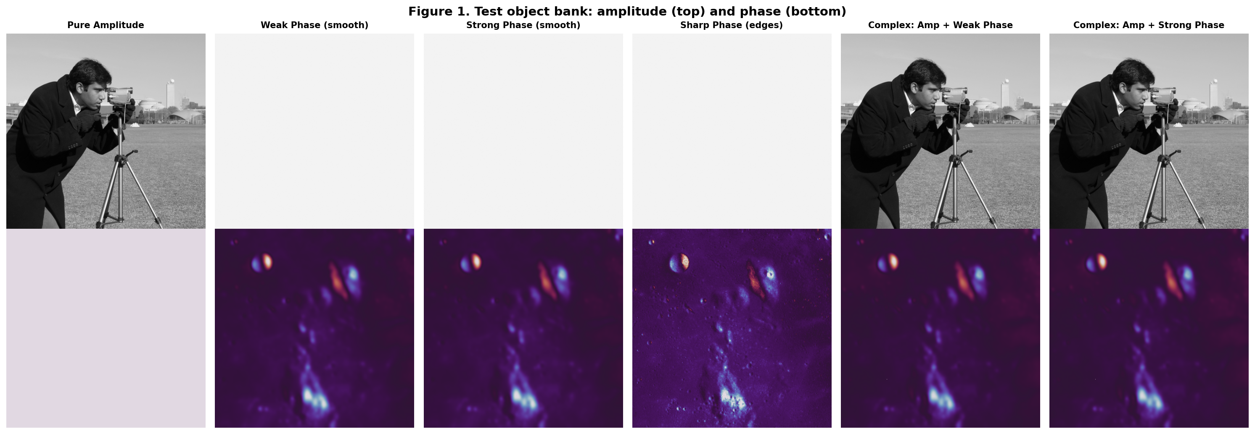
Figure 2 Test object bank: amplitude (top) and phase (bottom) channels of each category.

4. Results

4.1. Metric definition Sensitivity
The plain and per-frame-normalised Brenner gradients disagree sharply for a weak phase sample at NA = 0.20, the normalised version shows a spurious double-peak the plain version does not (Figure). The true, unscaled contrast at focus is only about 0.025% of the peak found elsewhere in the sweep; rescaling every candidate image to a common display range erases this three-order-of-magnitude difference and can manufacture curve structure with no optical basis. All subsequent results use the plain definition.
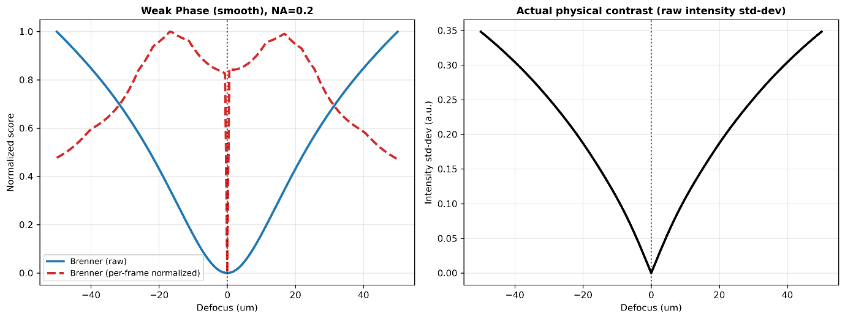
Figure 3 Left: plain (blue) vs. per-frame-normalised (red, dashed) Brenner curves for identical data. Right: the true physical contrast the normalisation discards.
With this definition fixed, the expected qualitative picture holds across the full object/NA grid: amplitude-bearing samples peak at true focus; phase samples dip there and rise on either side (Figure).
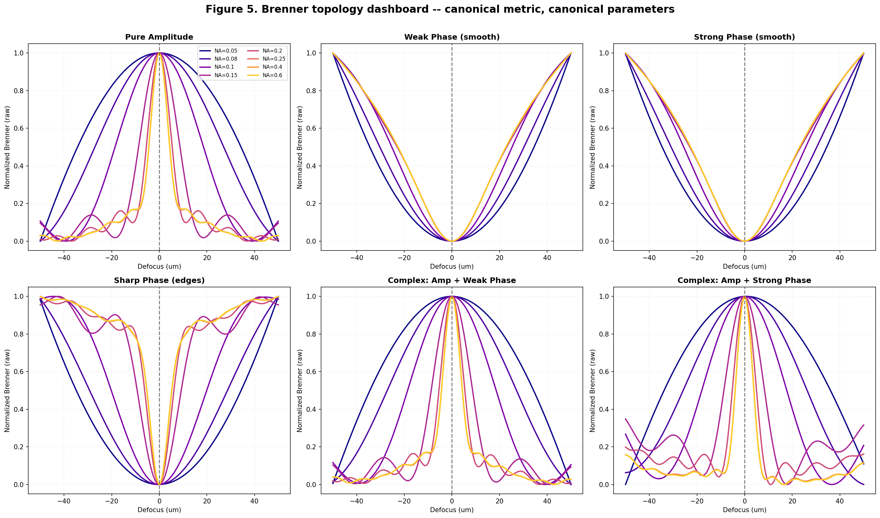
Figure 4 Brenner sharpness vs. defocus, all six sample categories, all eight tested NA values.

References:
All the claims in the report should be cited with proper references. Use Zotero (Zotero word plugin) to cite references.
See https://www.zotero.org/support/word_processor_plugin_installation for details.

